

INTRODUCTION
TO

INTERNSHIP PROGRAM

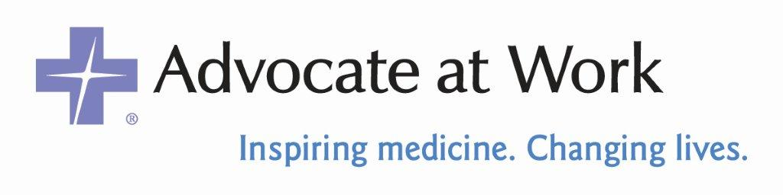

TABLE OF CONTENTS

Letter from the Internship Program Coordinators 2

Letter from Advocate Fitness Director 3

Advocate Fitness Mission and Vision 4

The “Medical Model” Concept 5

Intern Job Description/Application Process 6

Advocate Fitness Managed Sites and Locations 8

8550 W. Bryn Mawr Ave, Suite 650
Chicago, IL 60631
advocatehealth.com/advocateatwork

Phone: 773.295.3158
Fax: 847.698.4486

Dear Internship Coordinator and Student Intern:

Advocate Fitness is happy to offer one of the most comprehensive student internship programs in the Fitness and Health Promotion fields. We accept student interns throughout the year at all our managed fitness facilities.

Enclosed, you will find information regarding our many fitness facilities, as well as information on our program objectives and responsibilities and the student intern job description. If you are interested in pursuing an internship with us, simply review the application procedures also included in this booklet.

I hope this information helps you determine whether an internship with Advocate Fitness meets your needs and expectations. If you have any questions, feel free to contact me at 847-845-8355.

We look forward to working with you, as well as developing a solid skill set that will enhance the opportunities within Advocate’s infrastructure.

Sincerely,

Shane Cannon
Internship Coordinator
Advocate at Work – Advocate Medical Group
Advocate Health Care

Mission

The mission of Advocate Fitness is to be recognized as the leading provider of fitness and related health promotion management and consulting services to the greater Chicago area and select geographic markets. Advocate Fitness is dedicated to enhancing the personal and organizational health and well-being of employees and employers, in a variety of settings, through the development of fitness facilities, health promotion activities and comprehensive management services that are both cost effective and health effective solutions. Our goal is to be a provider of services that exceed our customer’s expectations of value while meeting our system’s financial and marketing objectives. In accomplishing our mission, we will strive to achieve outstanding teamwork, which provides challenging opportunities for our associates, while remaining consistent with a holistic philosophy and a commitment to Continuous Quality Improvement.

Advocate Fitness is extremely proud of the many locations that we have designed and currently manage within the greater Chicago area. All of our managed fitness facilities offer comprehensive fitness testing, ongoing exercise and motivational programs, monthly health/fitness lectures, informational bulletin boards and newsletters. Several of our centers offer daily aerobic classes, aquatic classes and monthly exercise incentive programs. Advocate Fitness organizes health fairs and presentations for the community and orchestrates the activities for National Employee Health and Fitness Day.

We take pride in our highly qualified staff. All managers and exercise physiologists have a minimum of a bachelor’s degree in their respective science sequence. Additionally, all staff is CPR/AED certified and professional staff is required to be certified by the American College of Sports Medicine (ACSM) upon initial employment or within six months. Many of the staff are also certified and actively involved in a number of well recognized health and fitness organizations, including the Association for Worksite Health Promotion, National Wellness Association, National Strength and Conditioning Association, Aerobic Council on Exercise, American College of Sports Medicine and the Wellness Council of Illinois. Our well-rounded staff includes experts in many areas such as weight training, group exercise, exercise psychology, health promotion and recreation.

Advocate Fitness has developed the “Medical Model” approach to fitness and health enhancement. This refers to the adoption of ACSM guidelines, including slight modifications when necessary, with the intent of offering a serious, prudent, and professional approach to personalized exercise and health programs. Under the guidance of a physician as medical director, all staff is aware of their limitations as professionals, and act quick to refer to the proper medical personnel when necessary. A major goal of the “Medical Model” approach is to educate all participants about the role that health and fitness plays in their lives.

Upon admission to any Advocate Fitness managed locations, all participants are required to have risk factors assessed and are referred into the Physician Referral Service, if necessary. Each participant receives a comprehensive fitness evaluation that includes assessment of strength, flexibility, body composition, aerobic capacity and blood pressure. Using this information, a detailed and personalized exercise prescription is written for each participant. A counseling session follows whereby participants are educated about the results of their testing and walked through their program by a professional staff member.
THE “MEDICAL MODEL” CONCEPT

The “Medical Model” approach to fitness and health enhancement used at all Advocate Fitness managed facilities refers to the adoption of principles and modification of guidelines from the American College of Sports Medicine (ACSM) with the intent of offering a serious, prudent and professional approach to both facility management and the development of personalized exercise and health programs. Under the supervision and guidance of a physician as medical director, along with a competent staff of health care providers including ACSM certified and master degreed exercise physiologists, a major objective becomes the education of all program participants. The exercise physiologists are aware of their limitations as professionals and are quick to refer to the proper medical personnel those individuals who exhibit high cardiovascular related risks/conditions or musculoskeletal concerns.

A major goal for the “Medical Model” approach is the education of all participants. This exercise and health component includes exercise theory, interpretation of fitness evaluations (and related test results) and exercise guidelines, utilizing participant goals in combination with specific limitations which may surface through routine health testing.

All participants are screened at the Fitness Center prior to admission into the program. An exercise assessment for strength, flexibility, body composition, aerobic capacity and blood pressure responses are required prior to participation. When necessary, physician clearance may also be required. A detailed exercise prescription and consultation complement the testing cycle, which is scheduled at timely intervals throughout the year.

Finally, all programs ascribe to an “interdisciplinary team approach” for quality health/fitness care which includes cooperative involvement from nutrition and physical therapy disciplines as well as from other system health care providers. Communications with participant’s personal physician, referral into the System’s Physician Referral Service, and affiliation with Advocate Health Care enhance consumer perception.

Quality Professionalism Cleanliness Service
JOB DESCRIPTION

POSITION DESCRIPTION: Position Number: None

Position Title: Student Intern

Division: Advocate Fitness

Classification: Student Intern, Non-Employee

Position Application Process: Send cover letter and current resume to:

Shane Cannon
1875 Dempster Street, Suite G01
Park Ridge, IL 60068
shane.cannon@advocatehealth.com

POSITION DIMENSIONS:

Reports to: Site Supervisor

Supervision Received: 95%

Supervision Exercised: Minimal supervision of center

Contacts: Staff, members, physicians, activity class participants, other health care providers.

POSITION OBJECTIVES:

- To offer practical experience in the administration and organization of hospital-based, commercial, wellness or corporate fitness facilities.
- To provide an opportunity to develop and refine the necessary technical and counseling skills needed in conducting health education, fitness evaluations, exercise prescriptions and programs.
- To enhance leadership and supervisory skills needed in coordinating fitness and exercise programs.
- Help prepare student intern for entry into the job market.
REQUIREMENTS:

Fields of Study
Physical Education, Exercise Science, Exercise Physiology, Adult Fitness, Corporate Fitness, Kinesiology, Biomechanics, Health Promotion and Sports Management.

Degree in Progress
Bachelors or Masters Degree

Certifications
Cardiopulmonary Resuscitation (CPR)/AED

Completed Readings
American College of Sports Medicine, Guidelines for Exercise Testing and Prescription; Competent in Chapters 1 through 8

Insurance Required
Proof of $1,000,000 personal liability insurance covered by university or self- funded. Healthcare Providers Service Organization (HPSO) is a good source.

Time Frame
Minimum 12-16 weeks and/or 400+ hours (shorter terms can be negotiated)

PRINCIPLE RESPONSIBILITIES:

(Note: The absence of specific statements of duties does not exclude those tasks from the position if the work is similar, related, or a logical assignment of the position.)

- Observation and administration of fitness assessments and related exercise/health tests to “apparently healthy” populations on a limited basis and with the supervision of an Exercise Physiologist; provide partial testing to members where necessary; implement safe and medically sound exercise prescriptions.
- Observation and administration of a variety of exercises classes; aerobic, aquatic and general fitness.
- Observation and administration of health/fitness presentation.
- Observation of all Advocate Fitness managed locations, sports medicine, and cardiac rehabilitation.
- Orientation of members and guests to specific equipment after reviewing health history questionnaire and setting mock exercise prescription.
- Provide coverage for front desk when necessary, provide tours for individuals and groups and answer any exercise questions/concerns appropriately.
- Contribute articles for newsletter and bulletin board.
- Create and implement a motivational project to be used in the center. Perform other duties as assigned.
MANAGED LOCATIONS

The following centers were designed by and are currently managed by Advocate Fitness.

ADVOCATE SUPPORT CENTER (ASCDG)
Location: Downers Grove, IL

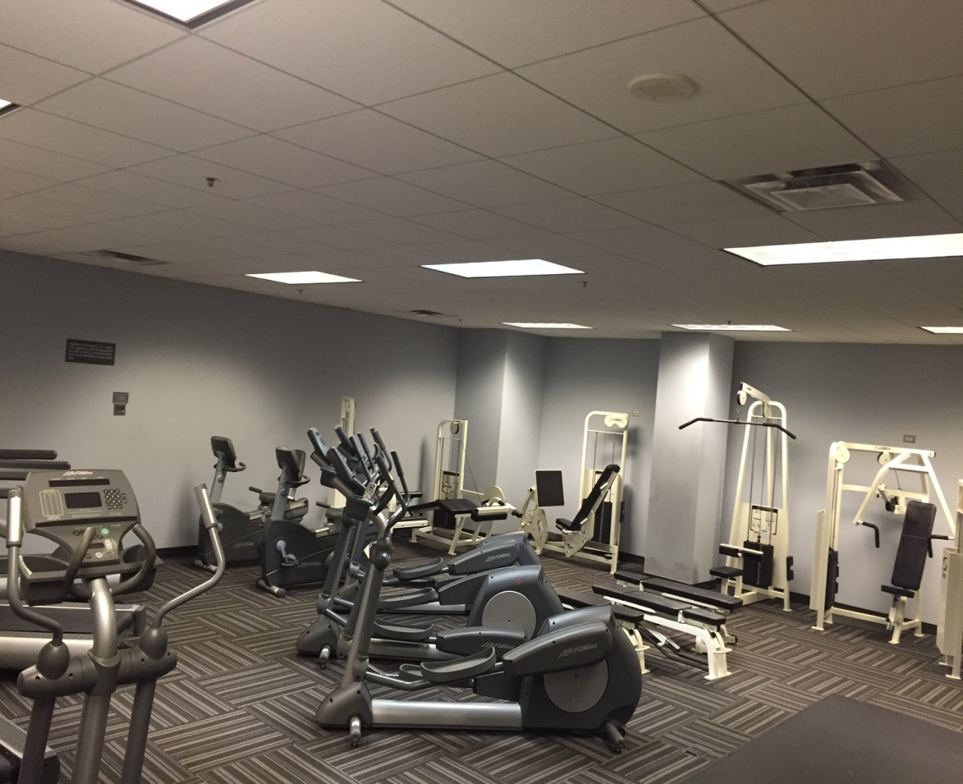
Advocate Health Care’s corporate headquarters in Downers Grove, Illinois is the site of Advocate Fitness Zone. This facility is 2,000 square feet. The fitness room includes free weights, machine weights, and a cable machine. There is also a multipurpose room where group exercise classes take place. There are numerous types of cardiovascular equipment which include treadmills, ellipticals and a bike (each equipped with its own flat screen T.V. monitor). The facility is also equipped with a full locker room and offers a certified massage therapist, personal training, and nutrition consultations.

BORG WARNER
Location: Bellwood, IL

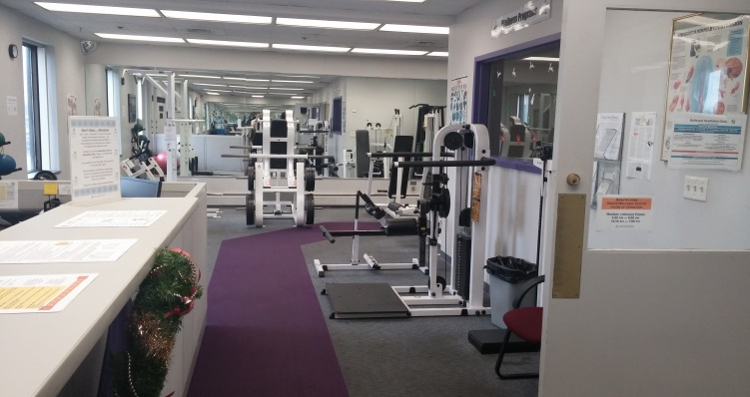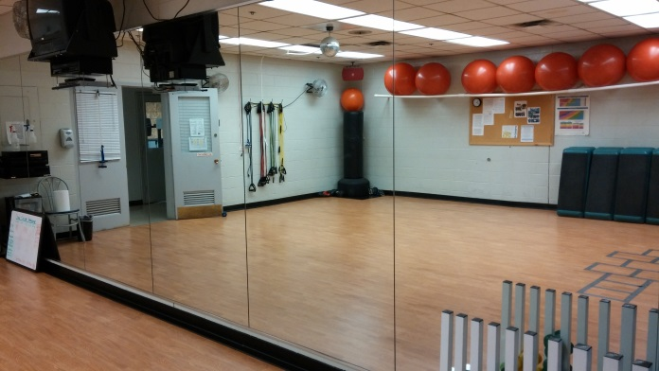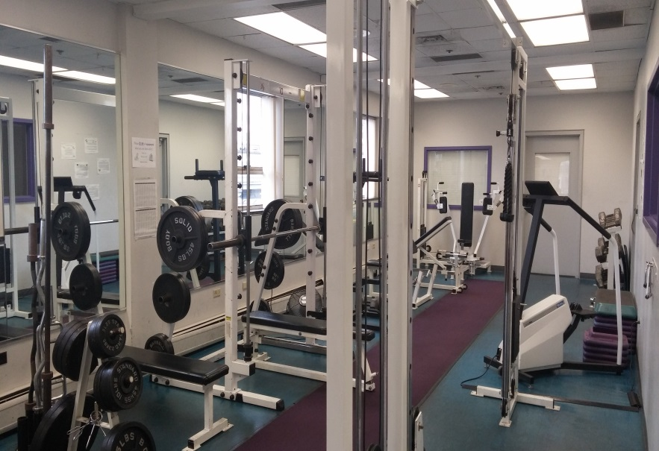

Borg Warner features a 4,500 square foot wellness center. Focused on overall health and well-being, the center offers strength training and the latest cardiovascular equipment, educational information, a group exercise studio, locker room facilities and a variety of programming options. In addition, the facility is highlighted by their Kinesiotherapy/Work-Reconditioning Program, a state-of-the-art, on-site, rehabilitation program for employees who are injured on the job or injured outside of work. Furthermore, Borg Warner’s overall membership participation and daily utilization rate are among the highest in the country for a manufacturing facility.

GRAINGER, INC.
Location: Lake Forest, IL

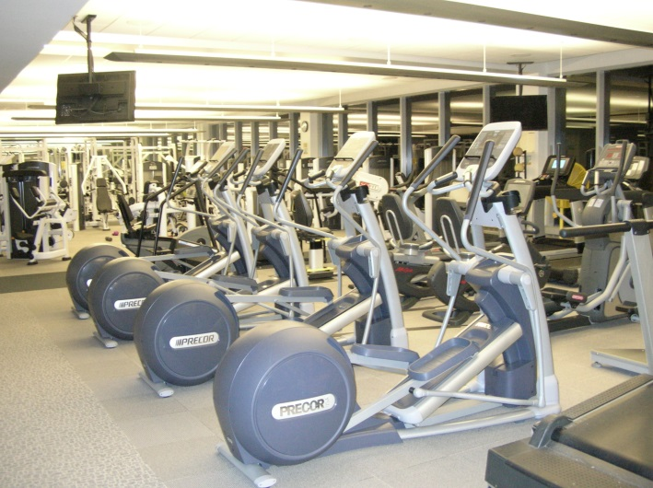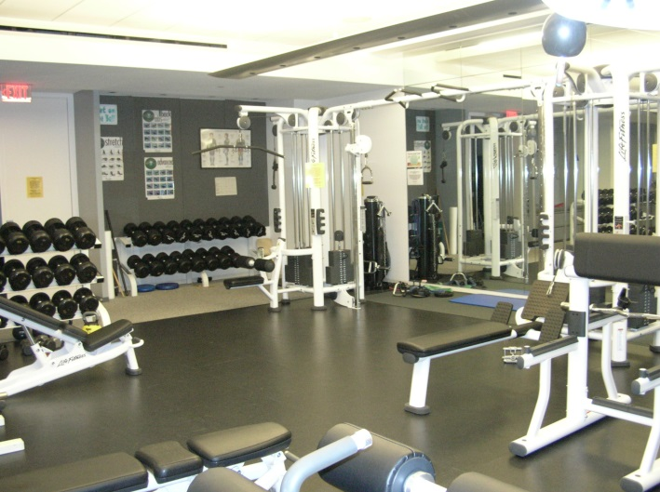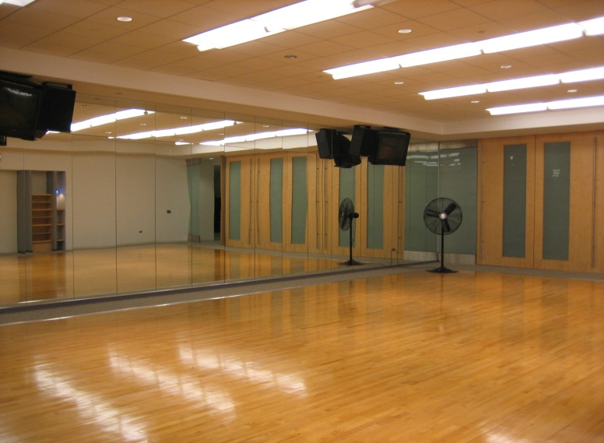

This 28,000 square foot state-of-the-art facility opened in April of 1999. The facility provides a cardiovascular area, weight training area, testing and counseling office, massage and table tennis room, a group exercise studio, locker rooms and an outdoor walking trail. The fitness center works in conjunction with employee health services to offer comprehensive prevention and risk reduction wellness programming. In addition, the fitness center staff offers numerous incentive programs throughout the year to encourage the members to join and utilize the facility.

LUTHERAN GENERAL HOSPITAL
Location: Park Ridge, IL

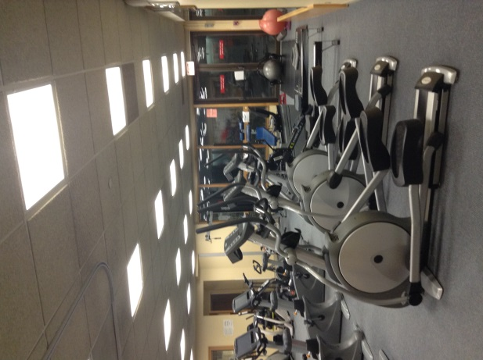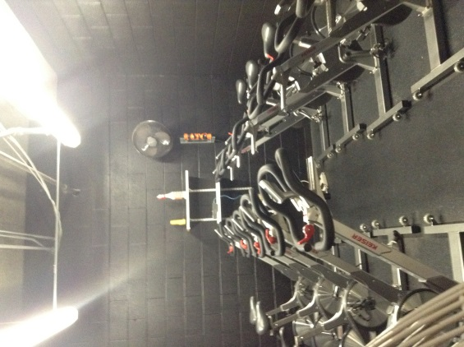

Opened in March 1983, the 12,000 square foot facility serves hospital employees (65% of membership base), medical staff, community members and referral patients from the system’s physicians. This fitness center provides a pool for swimming and aquatic classes, a cardiovascular room, a resistance training room and full lockers. Major programs include a “Heart Smart” group, Cardiac Rehabilitation and a Physicians Exercise Prescription Program. An architectural “Facility of Merit” award winner, Lutheran General’s Fitness Center was voted TOP FIVE of 130 facilities surveyed by Chicago Consumer Magazine.

NORTHERN TRUST BANK
Location: Downtown, Chicago, IL

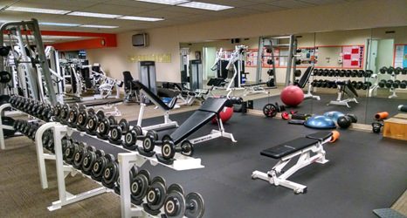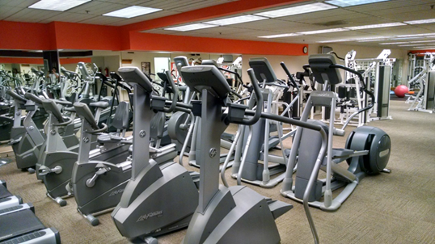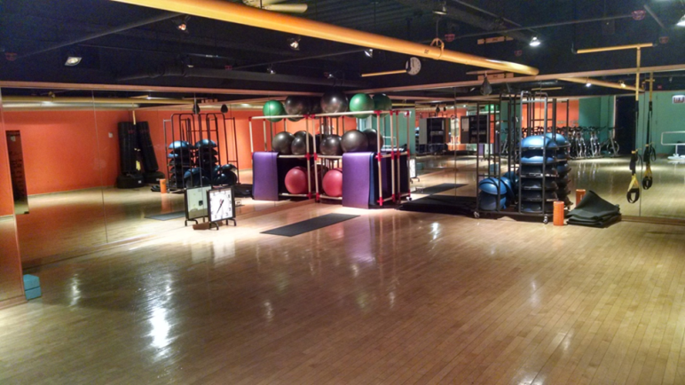

This 4,500 square foot fitness center includes an exercise testing and prescription room, cardiovascular area, weight training area, stretching area, full service locker room and a 1,000 square foot aerobic dance studio. This fitness center offers a comprehensive experience combining fitness with wellness. Major annual events include National Employee Health and Fitness Day and the Chase Corporate Challenge Race. Programs include nutrition analysis, weight loss counseling, health education brown bag lunches, group exercise classes, monthly incentive programs, monthly fitness newsletter and various wellness activities. Northern Trust has also earned the Silver Well Workplace Award from the Wellness Council of Illinois.

S&C ELECTRIC
Location: Evanston, IL

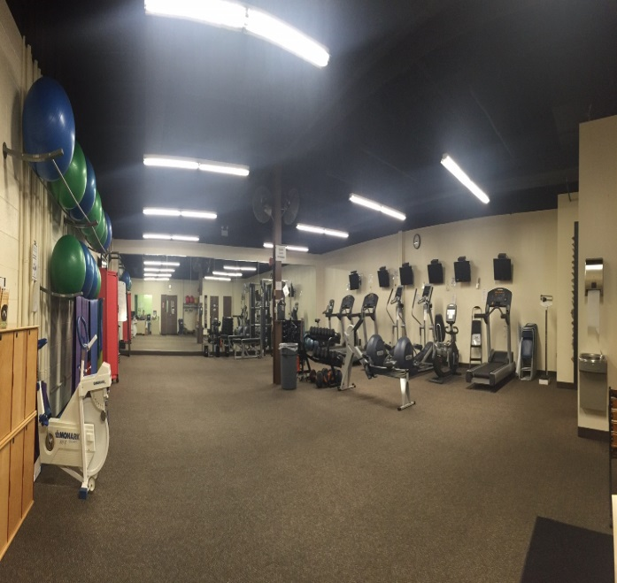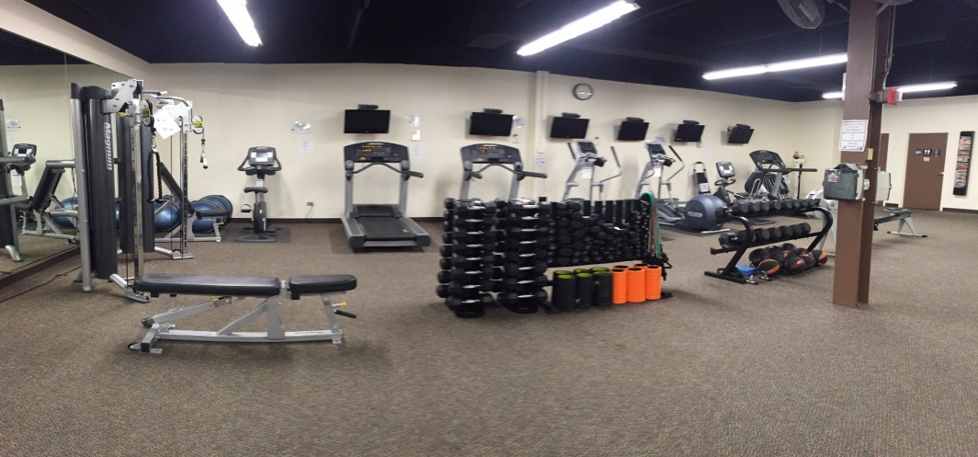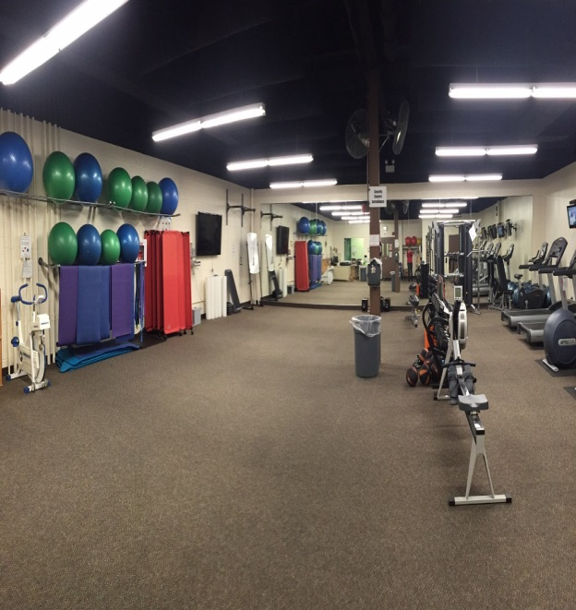
The S&C Wellness Center first opened its doors in May of 2011. Since then, this 2,210 square foot Wellness Center has helped reach personal goals in terms of health and overall well-being through a variety of group exercise classes, exercise equipment and aids, physical activities and challenges, educational offerings, clinical exercise programs and health screenings. Major programs include “AMP UP!”, which is an integrated program that helps participants understand their current health status and offers interventions to improve health outcomes. Also, S&C has recently developed a clinically based program called Hug Your Heart, for high-risk individuals.

