Eastern Illinois University



Extra Help Guide
for Managers

Department of Human Resources
July 2011


So you need more help!

We hope the following information will be helpful to you as you contemplate hiring Extra Help employees.

Do you need “Extra Help?”

Extra Help is a special category of Civil Service employee explained in Section 250.70 of the State Universities Civil Service System rules, in part, as follows:

- An Extra Help appointment may be made to any position for work the employer attests to be casual or emergent in nature and that meets the following conditions:
- the amount of time for which the services are needed is not usually predictable;
- payment for work performed is usually made on an hourly basis; and
- the work cannot readily be assigned, either on a straight-time or on an overtime basis, to a status employee.

Extra Help is designed for work that cannot be assigned to a status employee – even if it means paying overtime. You may not be sure how long this job may last, but you do NOT expect it to be a permanent situation – “emergent.”

- Qualification determination shall consist of a review of the employee's application and a verbal interview. Qualifications will be determined to be Acceptable or Not Acceptable. When skills are required for clerical/secretarial positions, an examination to demonstrate acceptable skills will be administered. The applicant will be required to pass the examination at a standard established by the employer. A listing of those applicants who have been determined to be Acceptable is maintained by the Employment Office.

Although taking and passing a Civil Service Exam is not necessary, an exam of some kind might be required depending on the skills required for the job you have. Otherwise, we review the applications we have on file to determine which individuals are qualified for the type of work you have available.

3) An employer shall fill an Extra Help position by referring persons to the employing unit from the Extra Help list of Acceptable candidates.

The Employment office will refer qualified candidates for you to consider for your Extra Help position.

- Acceptance or refusal to accept an Extra Help appointment by a candidate shall in no way affect the candidate's position on any Extra Help list, or on any other register maintained by the employer.

An individual who has been hired for an Extra Help position may continue to be on a hiring list (register) and is eligible to be selected for a status or full time appointment from that register.

- Classifications will be established in broad categories, such as administrative, professional, technical, clerical, trades, and service.

We have a list of Extra Help classifications that you might need. The classifications are general in nature.

6) An Extra Help position may be utilized for a maximum of 900 hours of actual work in any consecutive 12 calendar months. The employer shall review the status of the position at least every three calendar months. If at any time it is found that the position has become an appointment that is other than Extra Help, the employer shall terminate the Extra Help appointment. If an Extra Help position has accrued 900 consecutive hours, the position shall not be reestablished until six months have elapsed from the date of the termination of the position.

Once an Extra Help position is established, it may ONLY be used for 900 hours during any 12-month period. Every three months, the position must be reviewed to make sure it should not be a Status position. Once a position is used for 900 hours, that position may not be used for six months. We assign a position number to each position.

- Upon working 900 hours, an Extra Help employee cannot resume employment in any Extra Help appointment at a place of employment until 30 calendar days have elapsed.

In addition to the above 900 hour limitation on the position, no individual hired for Extra Help can work more than 900 hours at EIU in any position or combination of positions without a 30-day break.
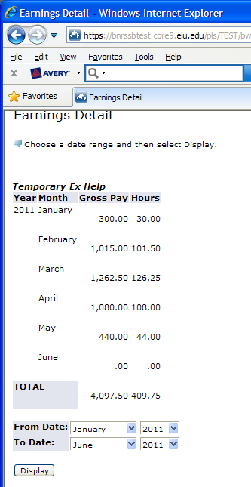
It is the supervisor’s responsibility to make sure an Extra Help employee does not work more than 900 hours. The easiest way to monitor hours worked is to ask the employee to submit an Earnings Detail from PAWS when they submit their timecard for approval. The Earnings Detail is available to the employee by selecting the Employee tab in PAWS. Under Pay Information, select Earnings History. Choose a date range that includes the time the employee has worked since he or she was hired for this position and display the results. The Earnings Detail is available by clicking on “Temporary Ex Help.” The report will only include hours as of the last completed pay period, so the supervisor will also have to consider the hours the employee worked during the pay period which has just passed. Keep in mind that the employee is limited to 900 hours total, regardless of how many Extra Help positions they may be working in.

You are Ready to Hire Extra Help!

When you determine you need Extra Help, submit a Personnel Authorization Request (PAR). The PAR is available at: http://www.eiu.edu/~humanres/forms/par_establish_fill.pdf
Identify the position as Temporary Civil Service. Once received, the Employment Office will work with you to find a great person to fill your Extra Help request. Remember this PAR ONLY authorizes 900 hours of work. Once the 900 hours is exhausted, you must submit another PAR. It is NOT generally necessary for you to submit a new PAR for each new Fiscal Year.

You Need an Extension!

An Extra Help appointee, upon reaching 900 hours of accumulated employment, must be terminated and cannot resume employment in any Extra Help Appointment until 30 calendar days have elapsed unless an extension is approved by the Executive Director of the University System. Consideration of an Extra Help extension request and any approved Extra Help extension shall follow the guidelines and application process outlined below.

If you find that you need an Extra Help employee to continue for more than the 900 hour limit, you will need to apply for an extension. The application for an extension and specific instructions are found at http://www.sucss.state.il.us/pm_manuals_results.asp?ID=54&kw= . Submit the application to the Employment Office for transmittal to the Systems Office. Please note that extensions need to be submitted to Systems at least 30-days before the 900 hours is expected to expire.

How Can We Help?

We will work with you to make sure you have the employees you need to do the work of your department. We understand that Extra Help is often an important element in your workforce. However, we must also ensure that Extra Help employees are not used to avoid establishing and filling Status Civil Service positions when they are appropriate.
We make every effort to monitor each position and employee to ensure the 900 hour limits on both positions and employees are not exceeded.

However, it is up to you, the hiring department to monitor your Extra Help employees, the work they are doing, and the hours they are working to make sure you do not exceed established limits.

The Civil Service rules on Extra Help are available at the State University Civil Service System Website at:
http://www.sucss.state.il.us/sar_report.asp?ID=Section 250.70&key=

For more information or answers to your questions, please contact:

Donna Noffke
217-581-3911
OR
eiu_employment@eiu.edu

