Create a major work of art
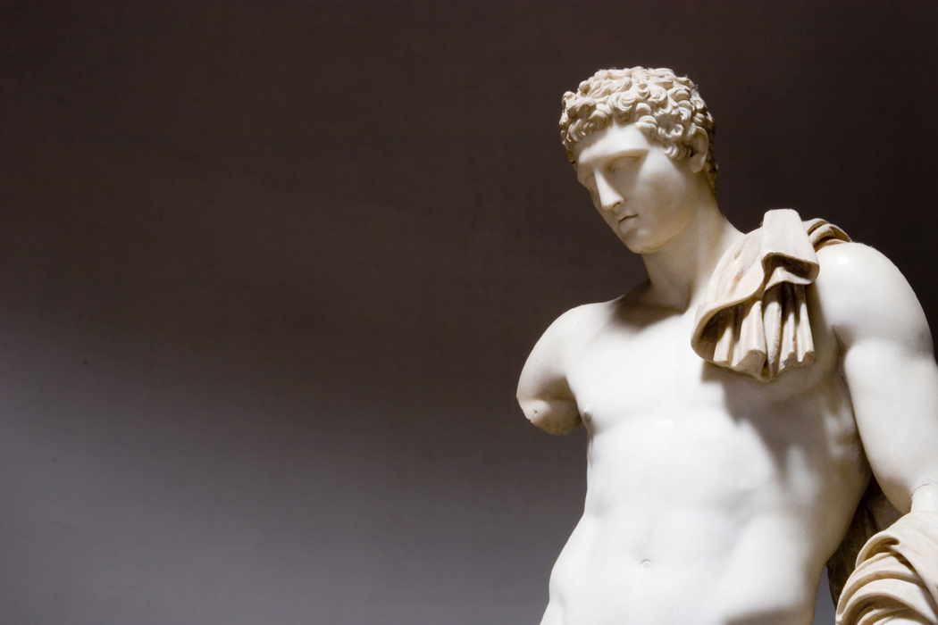

Unlimited shoes

Be a great inventor

Be a movie star


Be the best anything in the world

Guaranteed stability

Guaranteed happiness (never to be sad)


Being able to understand the opposite sex

Being able to understand yourself

Unlimited time travel

Love potion (anyone you desire will fall in love with you)

A drug that makes you happy with no side effects

The ability to fulfill all of your parents’ dreams for you

Rid the world of nuclear weapons

