From Bloom, et al., 1956 - These questions require a more extensive and elaborate answer. Below are the six question categories as defined by Bloom that can invoke higher order thinking or deeper learning.
- KNOWLEDGE – things memorized, but perhaps not with a full understanding
  - Remembering or memorizing, but perhaps not a full understanding
  - Recognizing, Listing, describing, identify, showing, labeling, collecting,
  - recalling identification and information, examining, tabulating, quoting, naming, defining
    - Who, what, when, where, how ...?
    - Describe in detail
- COMPREHENSION – you may understand information enough to explain it in your own words
  - interpreting; describe, predict, distinguish, discuss, estimate, extend
  - translating from one medium to another;
  - describing and summarizing in one's own words;
  - organization and selection of facts and ideas
    - Retell...
    - Can you summarize this in your own words?
- APPLICATION – finding some practical use for the information to solve other problems
  - problem solving; demonstrate, calculate, complete, illustrate, show
  - applying information to produce some result;
  - use of facts, rules and principles
    - How is...an example of...?
    - How is...related to...?
    - Why is...significant?
- ANALYSIS – break complex ideas into parts and see how the parts work together
  - subdividing something to show how it is put together;
  - finding the underlying structure of a communication;
  - identifying motives; order, arrange, divide, compare and select, analyze and select
  - separation of a whole into component parts
    - What are the parts or features of...?
    - Classify...according to...
    - Outline/diagram/or use this process...
    - How does...compare/contrast with...?
    - What evidence can you list for...?
- SYNTHESIS – make connections with things you already know
  - creating a unique, original product that may be in verbal form or may be a physical object;
  - combination of ideas to form a new whole, generalizing, predicting, inventing, designing, modify, rearrange, plan, create, rewrite, substitute, drawing conclusions
    - What would you predict/infer from...?
    - What ideas can you add to...?
    - How would you create/design a new...?
    - What might happen if you combined...?
    - What solutions would you suggest for...?
- EVALUATION - judging something’s worth
  - making value decisions about issues; resolving controversies or differences of opinion;
  - development of opinions, judgments or decisions, asses, rank, grade, support, summarize multiple ideas with further conclusions, compare for outcomes, discriminate, measure,
    - Do you agree...?
    - What do you think about...?
    - What is the most important...?
    - Place the following in order of priority...
    - How would you decide about...?
    - What criteria would you use to assess...?
Let’s use an example of what many students watch or play every fall – Are you ready for some Football?
Knowledge | The learner must recall information.  “Hey; I know what a football play is (sort of – I’ve seen John Madden drawing them on TV)” The student may not know much more than it is ‘a plan of action for games’.
Comprehension | The learner understands what is being communicated by so that he could explain it to someone. To really comprehend plays, the coach may show diagrams of each play and tell players where each person should be on the field and when plays might be used.
Application | The learner finds a practical use for in particular and concrete situations. Run (apply) the plays in the game!
Analysis | The learner can break down parts and see how they work together. Analyze what happened by viewing the films of the game. Talk about what worked well, and what didn’t.
Synthesis | The learner puts together elements or parts to form a whole. Run plays again in next practice with different players or modify the formations to make better plays.
Evaluation | The learner makes judgments about the value of the material or methods for a given purpose.  Evaluate in all future games; how and which plays would work when you need to use them.

Let’s Practice:

What level of Bloom’s Taxonomy would the following activities require? You may want to think about the highest level each could possibly be, and then determine what would be needed to take the task to an even higher level.

1.Changing a flat tire?

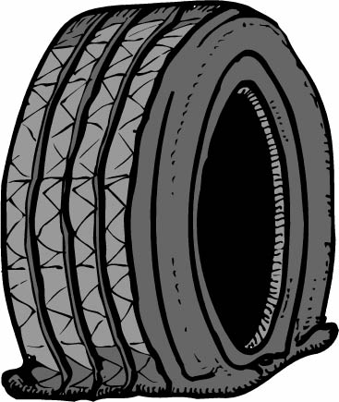

-Application

2. Finding the main idea of a paragraph



-Comprehension

3. Explaining the previous day’s class lecture to a student who was absent.



-Comprehension

4. Summarizing an article



-Comprehension

5. Finding the lowest common denominator for fractions

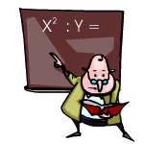

-Analysis

6. Choosing the correct answer to multiple choice questions

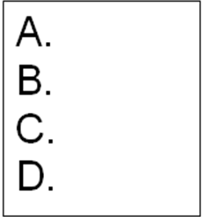

-Knowledge

7. Creating a webpage



-Synthesis

8. Appraising the cause and the damage to your car after a wreck.

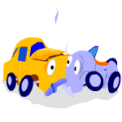
-Evaluation

9. Listing the USA states and their capitals.

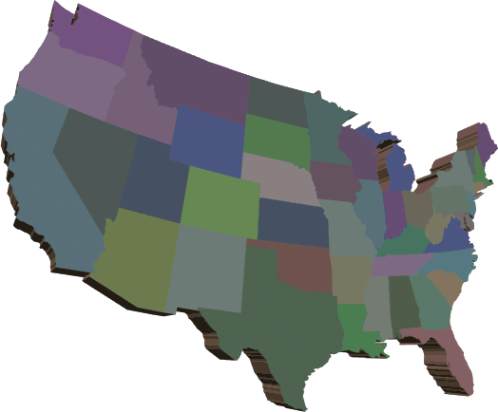

-Knowledge

10. Making your favorite and apple pie for your family.



-Application

11. Coming up with your own recipe for a baking contest

-Synthesis

12. Comparison shopping for the best buy



-Evaluation

13. Writing an essay for your English 1001G class



-Synthesis

14. Computing your GPA


-Application

Sources: http://www.officeport.com/edu/bloomq.htm http://frank.mtsu.edu/~studskl/

